CO1 ASSESMENT TOOL 2

AI-Based Smart Pharmaceutical Manufacturing Quality Assurance Platform

NAME :MUKESH RAJ L
REG NO:192571036
DEPT: B.TECH CS BS
COURSE CODE : CSA-1017
SOFTWARE ENGINEERING

1. Project Vision and Stakeholder Identification

1.1 Project Vision
The vision of the AI-Based Smart Pharmaceutical Manufacturing Quality Assurance Platform is to build an intelligent, automated, and reliable quality assurance system that continuously monitors pharmaceutical manufacturing processes using Artificial Intelligence (AI), Internet of Things (IoT), Computer Vision, and Cloud Computing. The platform aims to improve medicine quality, reduce manufacturing defects, minimize product wastage, automate regulatory compliance, and ensure patient safety.
Unlike conventional quality assurance systems that identify defects only after production, the proposed platform performs real-time monitoring and predictive analysis throughout the manufacturing process. AI-powered computer vision automatically detects defects in tablets, capsules, bottles, labels, and packaging, while machine learning models predict quality deviations before they become critical. IoT sensors continuously collect manufacturing parameters such as temperature, humidity, pressure, and equipment performance, enabling early detection of abnormalities.
The system also automates compliance reporting according to pharmaceutical regulatory standards, reducing manual documentation efforts and improving audit readiness. Additionally, complete batch traceability ensures every medicine can be tracked from raw material procurement to final product delivery.
The overall vision is to transform traditional pharmaceutical manufacturing into a smart, AI-enabled production environment that delivers high-quality medicines efficiently while reducing operational costs and improving regulatory compliance.

1.2 Project Objectives

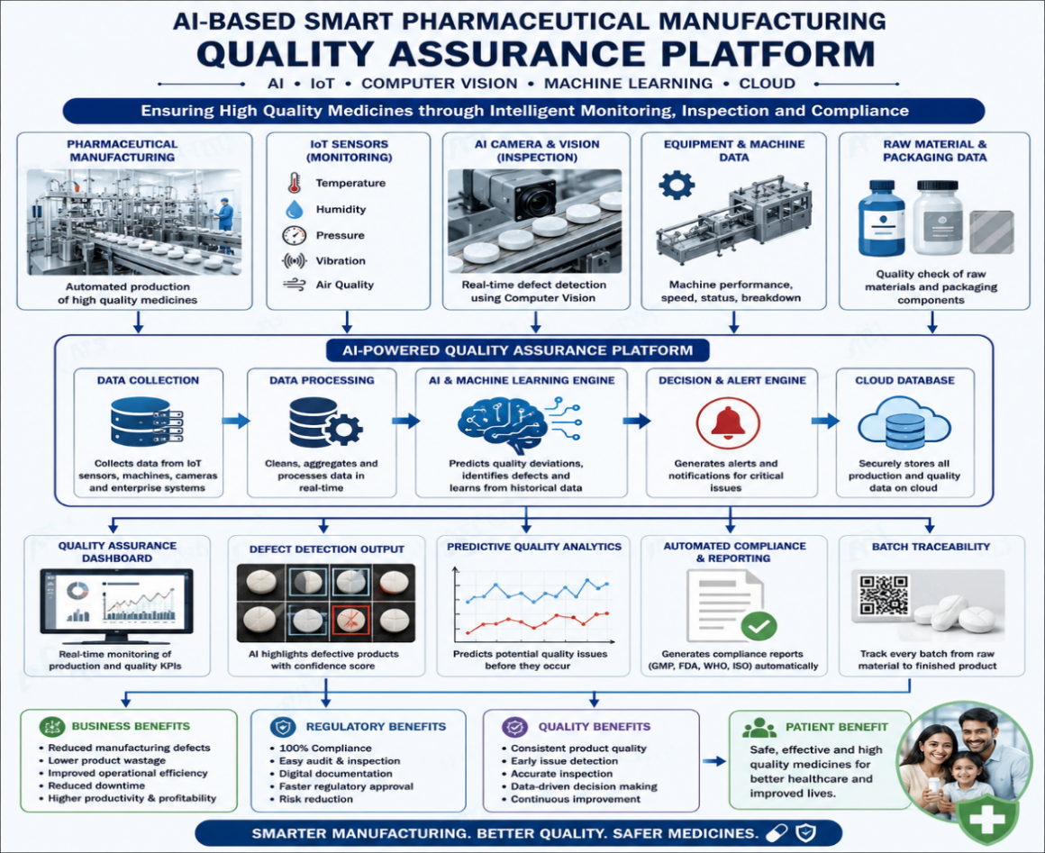

1.3 Key Features
The AI-Based Smart Pharmaceutical Manufacturing Quality Assurance Platform combines Artificial Intelligence (AI), Computer Vision, Internet of Things (IoT), and Cloud Computing to automate pharmaceutical quality assurance. The major features of the proposed system are described below.

1. Real-Time Production Monitoring
The platform continuously monitors manufacturing parameters such as temperature, humidity, pressure, and machine performance using IoT sensors. This enables early detection of abnormalities and helps maintain consistent production quality.

2. AI-Based Product Defect Detection
AI-powered Computer Vision automatically inspects tablets, capsules, bottles, and packaging for defects such as cracks, discoloration, incorrect labeling, and damaged packaging. This reduces manual inspection time and improves detection accuracy.

3. Predictive Quality Analytics
Machine Learning algorithms analyze production data to predict quality deviations before they occur. This allows manufacturers to take preventive actions, reducing product wastage and improving manufacturing efficiency.

4. Automated Compliance Reporting
The platform automatically generates quality assurance reports and compliance documents based on production data. This simplifies regulatory audits and minimizes manual documentation efforts.

5. Complete Batch Traceability
Every production batch is digitally tracked from raw material procurement to the finished product. This improves traceability and enables quick identification and recall of defective batches when required.

6. Smart Quality Assurance Dashboard
A centralized dashboard displays real-time production status, AI inspection results, machine performance, and quality metrics through interactive charts and reports, enabling faster and more informed decision-making.

7. Intelligent Alert and Notification System
The system instantly notifies operators and managers whenever abnormal production conditions or product defects are detected. Immediate alerts help reduce downtime and prevent further quality issues.

8. Cloud-Based Data Management
All production records, inspection results, and compliance reports are securely stored in the cloud. This ensures easy access, secure backup, and efficient management of manufacturing data.

1.4 Stakeholder Identification
The success of the platform depends on collaboration among several stakeholders.

Primary Stakeholders
Stakeholder | Role | Responsibility
Production Manager | Project Owner | Oversees production activities and decision making
Quality Assurance Manager | Quality Control | Validates medicine quality and approves batches
Factory Operator | End User | Operates manufacturing equipment and monitors production
Regulatory Officer | Compliance | Ensures compliance with pharmaceutical regulations
Plant Manager | Management | Monitors overall manufacturing performance
Maintenance Engineer | Technical Support | Maintains machines and IoT devices
AI Administrator | System Administrator | Maintains AI models and cloud platform
Pharmaceutical Company Management | Business Stakeholder | Reviews reports and strategic decisions
Warehouse Manager | Logistics | Tracks inventory and finished products
Patients | Final Beneficiary | Receive safe and high-quality medicines

Secondary Stakeholders
Stakeholder | Contribution
Drug Regulatory Authorities | Regulatory approvals
Software Development Team | Develops the application
Data Scientists | Train AI models
Cloud Service Provider | Stores manufacturing data
IoT Hardware Vendors | Supply sensors and devices
Packaging Team | Final packaging inspection
Suppliers | Provide raw materials

1.5 Stakeholder Responsibilities
The successful implementation of the AI-Based Smart Pharmaceutical Manufacturing Quality Assurance Platform depends on the active participation of various stakeholders. Each stakeholder has specific roles and responsibilities that contribute to the efficient operation, quality assurance, and regulatory compliance of the system.

1. Production Manager
The Production Manager supervises the overall manufacturing process and ensures that production targets are achieved without compromising quality. They monitor the production dashboard, review AI-generated alerts, and coordinate corrective actions whenever quality issues arise.

2. Quality Assurance (QA) Manager
The QA Manager is responsible for maintaining product quality throughout the manufacturing process. They verify AI inspection results, approve production batches, ensure compliance with pharmaceutical quality standards, and review automated quality reports.

3. Factory Operator
Factory Operators monitor machines and production lines on a daily basis. They respond to system alerts, operate manufacturing equipment according to standard procedures, and report any operational issues to the production team.

4. Regulatory Officer
The Regulatory Officer ensures that the manufacturing process complies with pharmaceutical regulations and industry standards such as GMP and FDA guidelines. They review compliance reports, maintain audit documentation, and support regulatory inspections.

5. AI Administrator
The AI Administrator manages the AI models, system configuration, and cloud platform. They monitor model performance, update machine learning algorithms when required, and ensure the security and reliability of the platform.

6. Maintenance Engineer
The Maintenance Engineer is responsible for maintaining manufacturing equipment, IoT sensors, and AI-enabled inspection devices. They perform regular maintenance, resolve technical issues, and ensure uninterrupted system operation.

7. Pharmaceutical Company Management
The management team reviews production performance, quality reports, and business analytics generated by the system. They use these insights to make strategic decisions, improve operational efficiency, and enhance overall productivity.

8. Patients (End Beneficiaries)
Patients are the ultimate beneficiaries of the platform. By ensuring consistent product quality and regulatory compliance, the system helps deliver safe, effective, and high-quality medicines to consumers.

1.6 Stakeholder Communication Matrix
Stakeholder | Information Required | Communication Method | Frequency
Production Manager | Production Status | Dashboard | Real Time
QA Manager | Defect Reports | Dashboard & Email | Hourly
Factory Operator | Machine Alerts | Mobile Notification | Instant
Regulatory Officer | Compliance Reports | PDF Reports | Daily
Plant Manager | KPI Dashboard | Dashboard | Daily
Management | Performance Report | Monthly Report | Monthly

1.7 Stakeholder Diagram
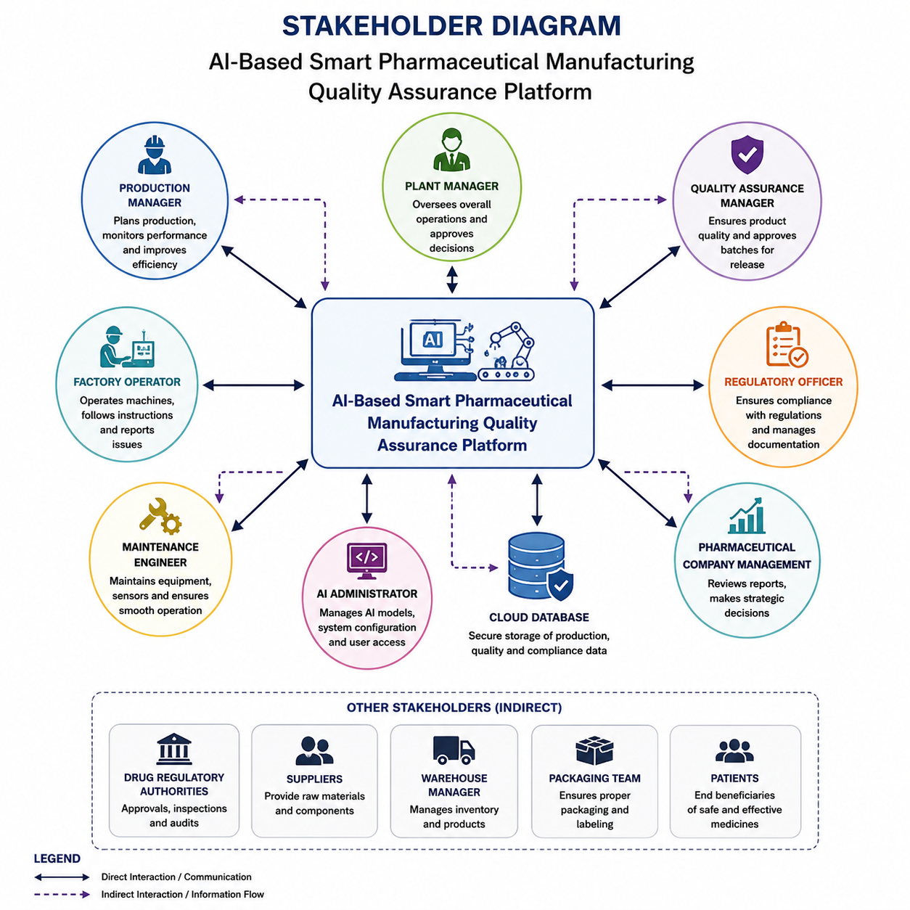

1.8 Expected Benefits
The implementation of the AI-Based Smart Pharmaceutical Manufacturing Quality Assurance Platform provides significant benefits to pharmaceutical manufacturers, regulatory authorities, healthcare providers, and patients. By integrating AI, IoT, Computer Vision, and Cloud Computing, the platform improves manufacturing quality, operational efficiency, and regulatory compliance.

Benefits to the Production Team
- Enables real-time monitoring of manufacturing processes.
- Reduces production downtime through early issue detection.
- Improves decision-making with live production insights.

Benefits to the Quality Assurance Team
- Automates defect detection with high accuracy.
- Reduces manual inspection effort and human errors.
- Improves consistency in product quality assessment.

Benefits to Regulatory Authorities
- Simplifies compliance verification through automated reports.
- Maintains complete digital records for audits.
- Ensures adherence to pharmaceutical regulations.

Benefits to Company Management
- Reduces manufacturing costs and product wastage.
- Improves operational efficiency and productivity.
- Supports strategic decision-making using analytical reports.

Benefits to Patients
- Ensures safe and high-quality medicines.
- Reduces the risk of defective pharmaceutical products.
- Improves overall patient safety and trust.

2. Agile Methodology

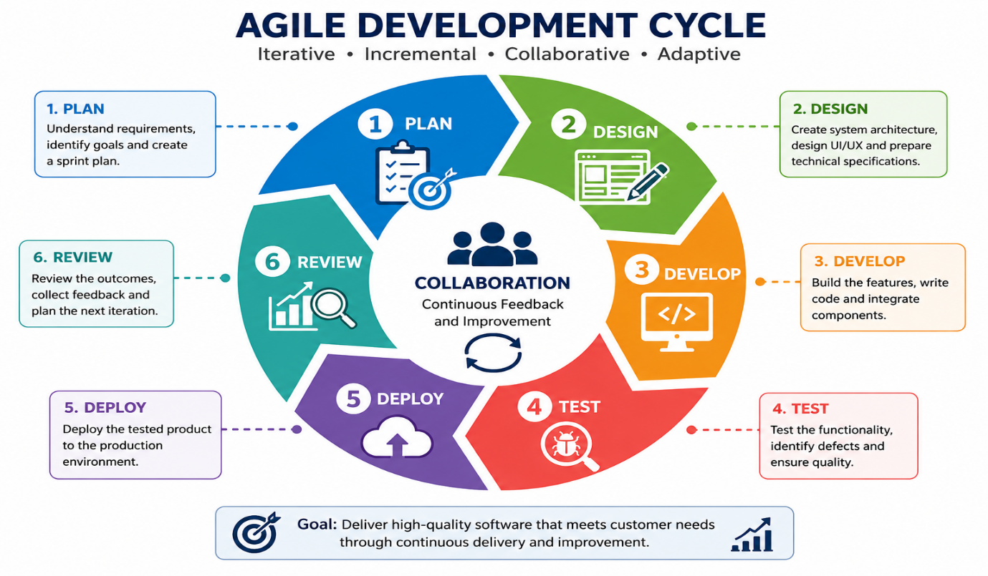

2.1 Introduction to Agile
Agile is a modern software development methodology that focuses on flexibility, collaboration, continuous improvement, and customer satisfaction. Instead of developing the entire system at once, Agile divides the project into smaller iterations called Sprints, allowing teams to deliver functional features incrementally.
For the AI-Based Smart Pharmaceutical Manufacturing Quality Assurance Platform, Agile enables continuous development, regular stakeholder feedback, and rapid adaptation to changing manufacturing and regulatory requirements.

2.2 Why Agile for This Project?
The pharmaceutical industry requires continuous monitoring, strict quality control, and frequent updates to comply with evolving regulations. Agile provides an effective development approach because it allows teams to deliver features incrementally while incorporating stakeholder feedback throughout the project lifecycle.

Advantages of Agile
- Faster feature delivery.
- Continuous stakeholder involvement.
- Early defect identification.
- Improved software quality.
- Better adaptability to changing requirements.
- Reduced project risks.

3. Scrum Framework
Scrum is one of the most widely used Agile frameworks for managing software development projects. It organizes work into short development cycles called Sprints, typically lasting two weeks. Each sprint delivers a functional increment of the software.
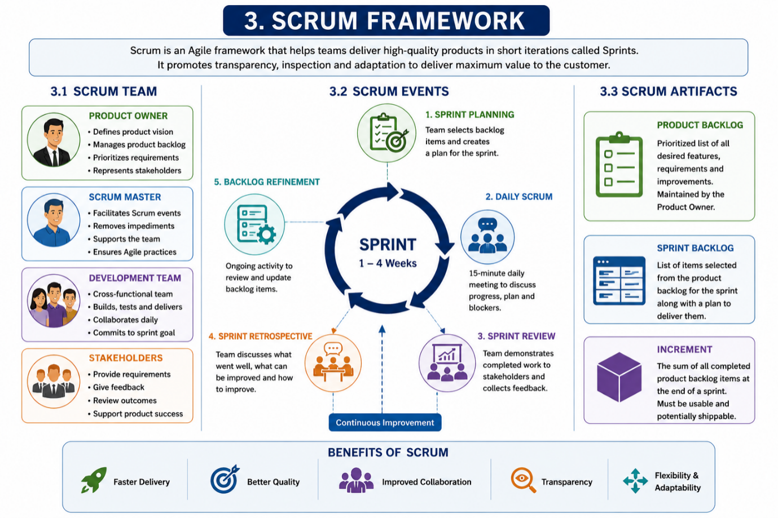

3.1 Scrum Team
Role | Responsibility
Product Owner | Defines product vision and prioritizes backlog
Scrum Master | Facilitates Scrum activities and removes obstacles
Development Team | Designs, develops, tests, and deploys the system
Stakeholders | Provide requirements and feedback

3.2 Scrum Events
Scrum Event | Purpose
Sprint Planning | Select user stories for the sprint
Daily Scrum | Discuss daily progress and blockers
Sprint Review | Demonstrate completed features
Sprint Retrospective | Identify improvements for the next sprint

4. Product Roadmap

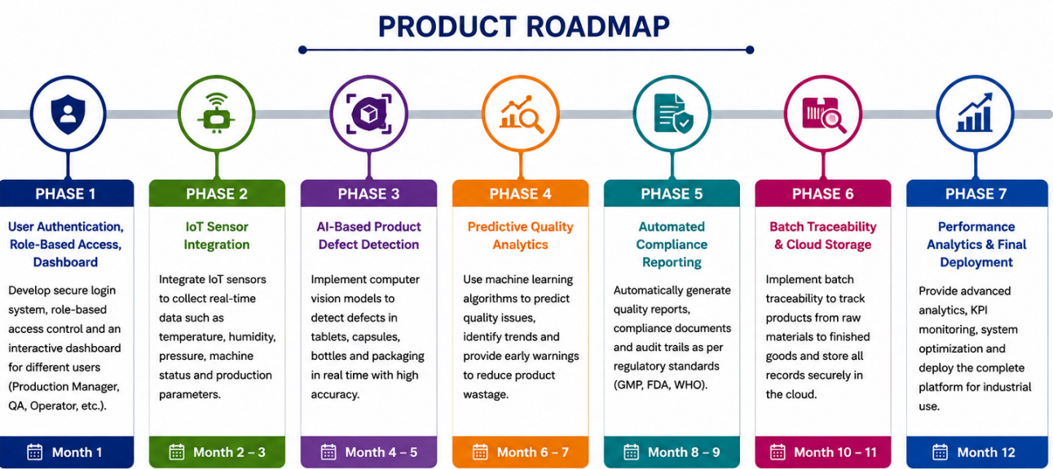

4.1 Introduction
A Product Roadmap is a strategic plan that outlines the major features and milestones to be developed throughout the project lifecycle. It helps the development team, stakeholders, and project managers understand the sequence of implementation and ensures that high-priority features are delivered first. For the AI-Based Smart Pharmaceutical Manufacturing Quality Assurance Platform, the roadmap is divided into multiple phases, with each phase focusing on delivering specific functionalities that contribute to the overall system.

4.2 Product Roadmap
Phase | Features | Expected Outcome
Phase 1 | User Authentication, Role-Based Access, Dashboard | Secure login system and centralized dashboard for different users.
Phase 2 | IoT Sensor Integration | Real-time collection of manufacturing parameters such as temperature, humidity, and machine status.
Phase 3 | AI-Based Product Defect Detection | Automatic identification of defective tablets, capsules, and packaging using Computer Vision.
Phase 4 | Predictive Quality Analytics | Machine Learning models predict quality issues before they occur, reducing product wastage.
Phase 5 | Automated Compliance Reporting | Generate quality reports and regulatory documents automatically for audits.
Phase 6 | Batch Traceability & Cloud Storage | Track every production batch and securely store manufacturing records in the cloud.
Phase 7 | Performance Analytics & Final Deployment | Generate business insights, monitor KPIs, and deploy the complete platform.

4.3 Product Roadmap Description
The project begins with the development of a secure authentication system and an interactive dashboard to provide controlled access to users. In the next phase, IoT sensors are integrated to collect real-time production data from the manufacturing environment. Once data collection is established, AI-based Computer Vision is implemented to detect product defects automatically.
The fourth phase focuses on predictive quality analytics, where Machine Learning algorithms analyze production trends and forecast potential quality issues. The fifth phase automates compliance reporting, making regulatory documentation faster and more accurate. Batch traceability and cloud-based data storage are then implemented to ensure complete product tracking and secure record management. Finally, the project concludes with performance analytics, system optimization, and deployment of the complete platform for industrial use.

5. Epics and User Stories

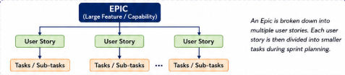

5.1 Introduction
In Agile methodology, an Epic is a large feature or business objective that is divided into smaller, manageable User Stories. User stories describe the system requirements from the end user's perspective, ensuring that development focuses on delivering value to stakeholders. Each user story follows the standard Agile format:
For the AI-Based Smart Pharmaceutical Manufacturing Quality Assurance Platform, the epics cover the major functionalities required to build a secure, intelligent, and efficient quality assurance system. These epics are further divided into user stories that will be implemented across multiple sprints.

5.2 Epics
Epic ID | Epic Name | Description
EP-01 | User Authentication & Role Management | Secure login and role-based access for all users.
EP-02 | Production Monitoring | Monitor manufacturing parameters using IoT sensors in real time.
EP-03 | AI-Based Defect Detection | Detect product defects automatically using AI and Computer Vision.
EP-04 | Predictive Quality Analytics | Predict quality issues using Machine Learning algorithms.
EP-05 | Compliance Reporting | Generate automated regulatory and quality assurance reports.
EP-06 | Batch Traceability | Track pharmaceutical batches throughout the production lifecycle.
EP-07 | Dashboard & Analytics | Display real-time production data, KPIs, and analytical reports.
EP-08 | Alert & Notification System | Notify users immediately when defects or abnormal conditions are detected.

6. Acceptance Criteria

6.1 Introduction
Acceptance Criteria are the specific conditions that must be satisfied before a user story is considered complete. They ensure that the developed functionality meets user requirements and provides a clear understanding of the expected outcome. In Agile projects, acceptance criteria help developers, testers, and stakeholders maintain a common understanding of the product requirements.

6.2 Acceptance Criteria for User Stories
User Story ID | Acceptance Criteria
US-01 | User should be able to log in securely using valid credentials, and unauthorized users must be denied access.
US-02 | The system should display real-time production parameters without delay.
US-03 | AI should detect product defects with high accuracy and highlight defective products automatically.
US-04 | The system should generate alerts immediately when abnormal production conditions are detected.
US-05 | Machine Learning should predict potential quality issues using historical and real-time data.
US-06 | Compliance reports should be generated automatically in a downloadable format.
US-07 | Every production batch should have a unique tracking ID and complete production history.
US-08 | Dashboard should display KPIs, production status, defect statistics, and quality reports accurately.
7. Product Backlog

7.1 Introduction
The Product Backlog is a prioritized list of all features, user stories, improvements, and bug fixes required to complete the project. The Product Owner continuously updates and prioritizes the backlog based on business value, stakeholder feedback, and project requirements.

7.2 Product Backlog
Priority | User Story ID | Feature | Business Value
High | US-01 | User Authentication | High
High | US-02 | IoT Production Monitoring | High
High | US-03 | AI Defect Detection | Very High
High | US-04 | Alert & Notification System | High
Medium | US-05 | Predictive Quality Analytics | High
Medium | US-06 | Compliance Reporting | Medium
Medium | US-07 | Batch Traceability | High
Low | US-08 | Dashboard Analytics | Medium

8. Sprint Planning

8.1 Sprint Goal
The primary goal of Sprint 1 is to develop the core functionalities required for secure access and production monitoring. This includes implementing user authentication, integrating IoT sensor data, and creating the initial dashboard for monitoring production activities.

8.2 Sprint Duration
Sprint Duration: 2 Weeks

8.3 Sprint Backlog
Task ID | Task | Assigned To | Status
T1 | Design Login Page | UI Developer | Completed
T2 | Develop Authentication Module | Backend Developer | Completed
T3 | Configure Database | Database Engineer | Completed
T4 | Integrate IoT Sensors | IoT Engineer | In Progress
T5 | Develop Dashboard | Frontend Developer | In Progress
T6 | Unit Testing | QA Engineer | Pending

9. Story Point Estimation

9.1 Introduction
Story Points are used in Agile to estimate the effort, complexity, and time required to complete each user story. Instead of measuring work in hours, story points help the development team estimate relative effort using the Fibonacci sequence.

9.2 Story Point Estimation
User Story | Story Points
User Authentication | 3
Production Monitoring | 5
AI Defect Detection | 8
Alert System | 5
Predictive Analytics | 13
Compliance Reporting | 5
Batch Traceability | 8
Dashboard Analytics | 3

10. Sprint Goal
The Sprint aims to establish the foundation of the AI-Based Smart Pharmaceutical Manufacturing Quality Assurance Platform by implementing secure user authentication, integrating IoT-based production monitoring, and developing an initial dashboard. At the end of the sprint, users should be able to log in securely, monitor production parameters in real time, and access a functional dashboard for quality monitoring.

11. Sprint Deliverables
At the end of the sprint, the following deliverables are expected:
- Functional user authentication system.
- Role-based access control.
- IoT sensor integration for production monitoring.
- Initial AI-ready production dashboard.
- Product backlog and sprint backlog documentation.
- Acceptance criteria validation report.
- Sprint review and retrospective report.

12. Conclusion
The AI-Based Smart Pharmaceutical Manufacturing Quality Assurance Platform applies Agile principles to develop a secure, intelligent, and scalable quality assurance solution for pharmaceutical manufacturing. By integrating Artificial Intelligence, Computer Vision, IoT, and Cloud Computing, the platform enhances product quality, reduces manual inspection, ensures regulatory compliance, and improves operational efficiency. The Agile approach enables continuous feedback, iterative development, and timely delivery of high-value features, ensuring that the final product effectively meets stakeholder requirements and industry standards.
Bottom of Form

